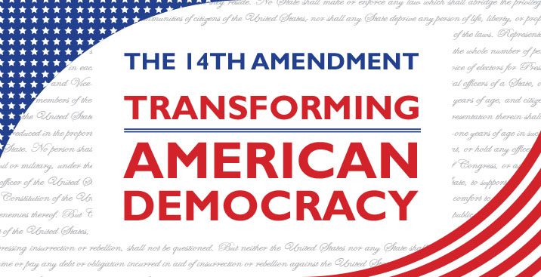

MUSKEGON COUNTY BAR ASSOCIATION LAW DAY 2017
12th GRADE SPEECH CONTEST

The 14th Amendment to the Constitution was ratified on July 9, 1868, after the Civil War, and granted citizenship to all persons born or naturalized in the United States. In addition, it forbids states from denying any person life, liberty, or property without due process of law or to deny any person equal protection under the law. Through its Citizenship, Due Process and Equal Protection clauses, this transformative amendment advanced the rights of all Americans. The 14th Amendment is cited in more litigation than any other amendment and is a source of inspiration for all those who advocate for equal justice under law.

QUESTION: The topic to be answered in speech format is:

The 14th Amendment protects a person’s right to be treated equally under the law. The Supreme
Court has ruled that discrimination based on race, gender, religion, or national origin is unconstitutional. However, when evaluating applicants for admissions, colleges examine a number
of variables, including these, when deciding whether to accept a student. Should colleges be
allowed to factor a student’s race and gender as part of the admissions process?

Students may wish to review the following materials before preparing speeches:

1. https://supreme.justia.com/cases/federal/us/572/12-682/case.pdf
2. http://caselaw.findlaw.com/us-supreme-court/539/306.html
3. https://supreme.justia.com/cases/federal/us/539/244/case.pdf

Speeches must be no longer than FOUR MINUTES. We encourage students to take a position and support that position with research, data, and material. Students should also be aware of the contrary position and be able to argue and support why their position on the issue is better.

Awards for 12th Grade Speech Contest Winners are as follows:

1st Place: $2,000.00 Scholarship 2nd Place: $1,000.00 Scholarship
3rd Place: $500.00 Scholarship 4th Place: $250.00 Scholarship

EACH SCHOOL IS LIMITED TO THREE STUDENTS. However, we do have the discretion to allow more participants. TEACHERS: Please submit any questions and the names of your final three students to:

Jenny McNeill
Ladas Hoopes McNeill Law, PLC
435 Whitehall Road
North Muskegon, MI 49445
(231) 744-6218
jennymcneill@comcast.net
MUSKEGON COUNTY BAR ASSOCIATION LAW DAY 2017
12th GRADE SPEECH CONTEST ENTRY FORM

Student’s Full Name: ______________

Student’s Home Phone Number:____________________________ Student’s Age:__________

Student’s Email Address: __

Parent(s) Names(s):________________________________________________________________

Parent’s Email Address: __

Name of School: ________

Name of Teacher:_____________________________ School Phone Number:________________

Name of College Planning to Attend:__________________________________________________

College Identification number (if available):____________________________________________

Guests Attending the luncheon (limit 2 guests per student):________________________________

Signature of Entrant: __

Eligibility: Muskegon County 12th grade students.

Notification: Speech contest will be held at the MAREC Center on April 28, 2017. All
participants in this contest are invited to attend the Muskegon County Bar
Association Law Day Luncheon at the Lake House on April 28, 2017, from 11:30am – 1:00pm.
Winners will be announced at the luncheon.

Deadline: Entries must be received by 5:00 pm April 14, 2017.

Requirements: A completed entry form must be submitted for each contestant.

Submit to: Jenny McNeill
Ladas Hoopes McNeill Law, PLC
435 Whitehall Road
North Muskegon, MI 49445
(231) 744-6218 jennymcneill@comcast.net

